Exercise: Traffic Lights Simulation

In this exercise you are going to build this application.

in order to simulate the traffic light sequence (called signs 01–04). These images are as below and will be made available in the lab:

Red
Red/Amber
Amber
Green

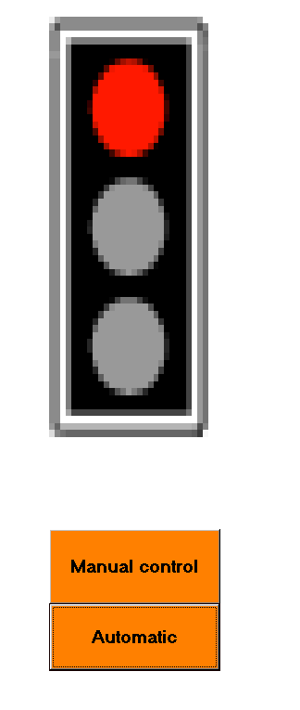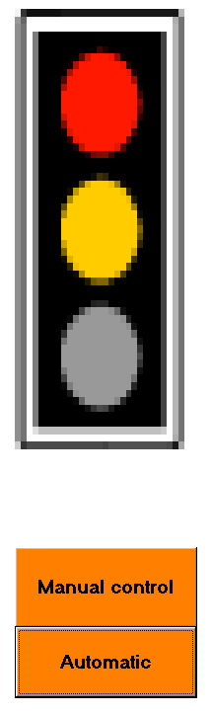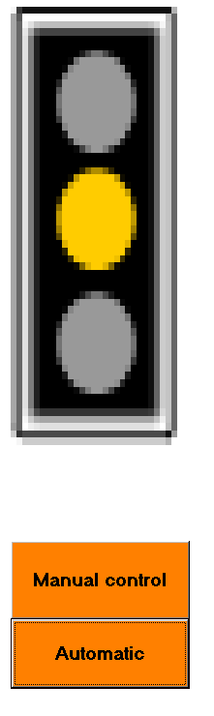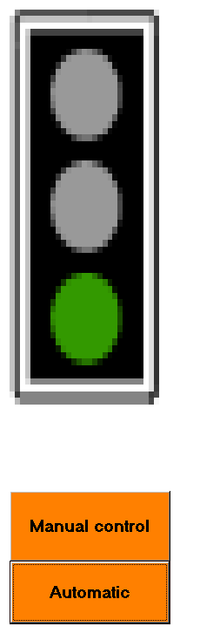

A single image control on the form is used to hold the images and the images are replaced in a loop that simulates the changing of the traffic lights. Within the loop there is a selection statement to simulate the changing of the lights i.e. replace an image depending on the previous:

If red then replace with red/amber

The controls used are as seen here:

One image control that will hold the image files.

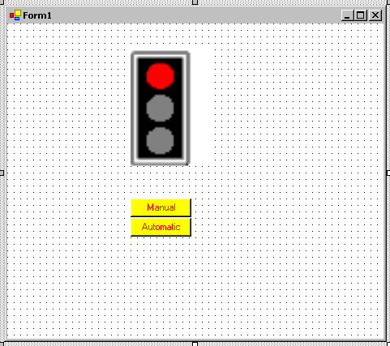

Command buttons.

Also add a Timer control

Example of a programming statement to load a picture:

pictureBox1.Image = Image.FromFile("E:/signs01.bmp");

The project allows both automatic changing and for the user to take manual control. With manual control the next light in the sequence is changed with each click of the manual button. The manual control effectively turns off the timer, which is used for the automatic sequence.

Demonstration of the use of the Timer

Settings that are important are the interval property which sets the timer to execute at the interval stated. When the timer executes the code associated with the event executes. Therefore the code written for this timer will execute every three seconds. If the enabled property is set to false the timer will be effectively switched off and the code will not execute. Set the enabled property to true switches the timer on.

Try this code for the default timer event:
Clicking on the control generates this default event.
The identifier I is set to 1 prior to entry

private void timer1_Tick(object sender, System.EventArgs e)
{
I++;
nextlight();
}

This code will execute after the interval time set in the control's interval property. In this case it has been set to 3000 milliseconds i.e. 3 second2. Therefore the code will execute after one second and again after another second and continue executing each and every second.

Programming statements to control the timer:

timer1.Enabled = true; - switch the timer on
timer1.Enabled = false; – switch the timer off

Build your own simulation of this project.

